THE UNIVERSITY OF BUEA

P.O BOX 63 REPUBLIC OF CAMEROON

Buea, Southwest Cameroon Peace -Work-FatherLand

Tel: (237) 674354327

Fax: (237) 3332 22 72

**FACULTY OF ENGINEERING AND TECHNOLOGY**

**DEPARTMENT OF COMPUTER ENGINEERING** (SOFTWARE)

**COURSE TITLE: XML AND DOCUMENT CONTENT VALIDATION**

**COURSE CODE: CEF 482**



**A SIMPLE DTD FOR AN ONLINE STORE**



**Course Supervisor:** **Dr. SOP DEFFO**

**2023/2024**

## Group Members

|  |  |  |
| --- | --- | --- |
|  | **NAMES** | **MATRICULE NUMBERS** |
| **1.** | **ENOW MYKE-AUSTINE ETA** | **FE21A183** |
| **2.** | **FOLETIA AJONGAKUE SYNCLAIR** | **FE21A190** |
| **3.** | **INDAH RICOBELLE MBAH** | **FE21A204** |
| **4.** | **KENFACK SAMEZA** | **FE21A213** |
| **5.** | **MOKFEMBAM FABRICE KONGNYUY** | **FE21A240** |
| **6.** | **MONDOA ROBERT** | **FE21A241** |
| **7.** | **QUINUEL TABOT NDIP-AGBOR** | **FE21A300** |
| **8.** | **SIRRI THERESIA ANYE** | **FE21A306** |
| **9.** | **TAKEM JIM** | **FE21A309** |
| **10.** | **TSAPZE ZAMBOU ROSELINE** | **FE21A328** |
| **11.** | **TIANI PEKINS EBIKA** | **FE21A325** |

Table of Contents

I) INTRODUCTION 4

II) CURRENT PRODUCT CATALOG STRUCTURE 4

III. DATA ANALYSIS 4

IV. ADVANTAGES OF DTD-BASED APPROACH 5

V. IMPLEMENTATION 6

VI. CONCLUSION 8

VII) REFERENCES: 9

# INTRODUCTION

This report analyzes the current state of the online store's product catalog, focusing on its structure, data elements, and potential improvements. The report utilizes a Document Type Definition (DTD) as a foundational framework for data organization.

A DTD (Document Type Definition) defines the structure and data elements for your product catalog. This ensures consistency, improves search, and facilitates data exchange with other systems.

# II) CURRENT PRODUCT CATALOG STRUCTURE

The current product catalog likely utilizes a database or flat file system to store product information. However, without specific details, we can analyze a potential structure using a DTD.

* **Root Element:** <catalog> - This element serves as the container for all product data within the catalog.
* **Product Element:** <product> - Represents an individual product within the catalog. Each product element contains child elements with specific data points.
  + <id>: Unique identifier for the product (e.g., number).
  + <name>: Product name (e.g., T-Shirt).
  + <category>: Category the product belongs to (e.g., Clothing).
  + <price>: Product price (e.g., 19.99).
  + <availability>: Stock availability status (e.g., In Stock).

# III. DATA ANALYSIS

The current structure provides a basic framework for storing product information. However, for a robust and scalable catalog, some improvements can be considered:

* **Data Enrichment:** Expand the data captured for each product. Consider including:
  + <description>: Detailed product description.
  + <image>: Link or reference to product image(s).
  + <brand>: Brand associated with the product.
  + <specifications>: Technical specifications relevant to the product (e.g., size, color, material).
* **Data Hierarchy:** Implement a hierarchical category structure using nested elements. This allows for subcategories within main categories (e.g., Clothing > Shirts > T-Shirts).



* **Inventory Management:** Include additional elements for inventory management:
  + <stock_level>: Current stock quantity.
  + <low_stock_threshold>: Minimum stock level before triggering a reorder.

# IV. ADVANTAGES OF DTD-BASED APPROACH

Using a DTD for the product catalog offers several advantages:

* **Data Validation:** Ensures data consistency and eliminates errors by defining the expected structure and data types for each element.
* **Improved Search and Filtering:** Categorization and enriched data allow for better search functionality and product filtering for customers.
* **Scalability:** The DTD can be easily extended to accommodate new data points as the product catalog grows.
* **Data Exchange:** A well-defined DTD facilitates easier data exchange with other systems or platforms.

# V. IMPLEMENTATION

**CASE STUDY: AMAZON**

Amazon, the e-commerce giant, manages a vast product catalog encompassing millions of items. While their current system is undoubtedly efficient, a Document Type Definition (DTD) approach could offer additional benefits in terms of data consistency, scalability, and potential future integrations.

**Challenges of Amazon's Current System**

* **Data Silos:** Amazon likely utilizes various databases and systems to manage product information across different categories. This can lead to inconsistencies in data structure and definitions.
* **Scalability:** As new product categories and features emerge, the current system might require complex modifications to accommodate the evolving data landscape.
* **Data Exchange:** Integrating product data with external systems or marketplaces could be hindered by the absence of a standardized data structure.

**How a DTD Could Benefit Amazon**

* **Standardized Structure:** A DTD would define a consistent structure for all product data across categories, ensuring a unified approach to data management.
* **Improved Search and Filtering:** With standardized data elements like categories, specifications, and attributes, Amazon could refine its search and filtering functionalities for a more user-friendly customer experience.
* **Enhanced Scalability:** The DTD can be easily extended to include new data elements as Amazon expands its product offerings or incorporates new features.
* **Simplified Data Exchange:** A well-defined DTD facilitates seamless data exchange with third-party vendors, marketplaces, or internal systems.

**Implementation Considerations for Amazon**

* **Phased Approach:** Implementing a DTD for Amazon's entire catalog at once would be a massive undertaking. A phased approach, starting with a pilot category, would allow for testing and refinement before broader adoption.
* **Data Mapping:** Mapping existing product data to the new DTD structure would be a crucial step. Automation tools and data migration strategies can streamline this process.
* **System Integration:** The DTD should be integrated with existing product management systems, search algorithms, and potentially external platforms for seamless data flow.

**Potential Future Applications**

* **Voice Search Optimization:** A DTD-based structure could improve Amazon's voice search functionality by ensuring data is tagged and categorized consistently.
* **Personalized Recommendations:** With a standardized data structure, Amazon could leverage customer data and purchase history to provide more personalized product recommendations.
* **Vendor Onboarding:** A defined DTD could streamline the process for new vendors listing products on Amazon's marketplace, reducing errors and inconsistencies.

**CODES**

<!ELEMENT catalog (product+)>

<!ELEMENT product (id, name, category, price, availability)>

<!ELEMENT id (#PCDATA)>

<!ELEMENT name (#PCDATA)>

<!ELEMENT category (#PCDATA)>

<!ELEMENT price (#PCDATA)>

<!ELEMENT availability (#PCDATA)>

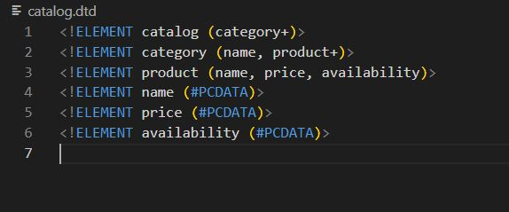

• <catalog> is the root element and it must contain one or more <product> elements.

• <product> element contains information about a single product. It includes child elements for id, name, category, price, and availability.

• Each child element of the <product> element is of type (#PCDATA), which means it contains character data.

<catalog>

<product>

<id>1</id>

<name>T-Shirt</name>

<category>Clothing</category>

<price>19.99</price>

<availability>In Stock</availability>

</product>

<product>

<id>2</name>

<name>Jeans</name>

<category>Clothing</category>

<price>29.99</price>

<availability>In Stock</availability>

</product>

</catalog>

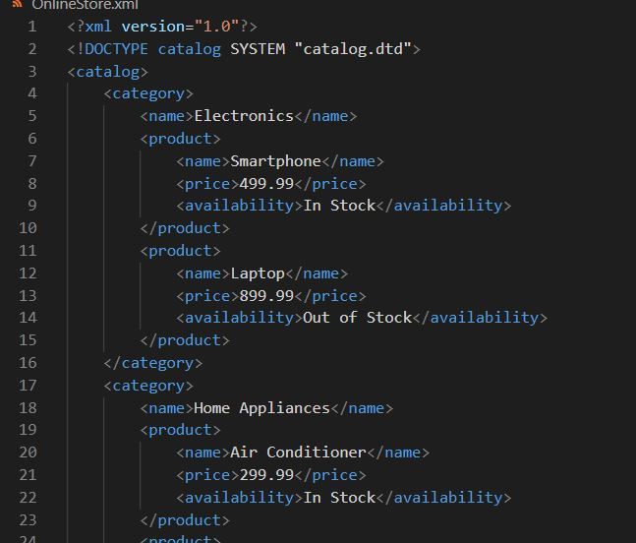

# VI. CONCLUSION

Implementing a DTD for the product catalog can significantly improve its organization, maintainability, and functionality. This report provides a framework for optimizing the product catalog and enhancing the overall customer experience within the online store.

# VII) REFERENCES:

• **Document Type Definition (DTD):**

* W3Schools DTD Tutorial: <https://www.w3schools.com/xml/xml_dtd_intro.asp>

• **XML Schema (XSD):**

* W3Schools XSD Tutorial: <https://www.w3schools.com/xml/xml_schema.asp>

• **Ecommerce Product Catalog Best Practices:**

* BigCommerce: Guide to Building a High-Converting Product Catalog: <https://support.bigcommerce.com/s/article/Adding-Your-Catalog>
* Shopify: Optimizing Your Product Catalog for SEO and Sales: <https://help.shopify.com/en/manual/promoting-marketing/seo>